What is JavaScript?

A high-level definition
every time a web page does more than just sit there and display static information for you to look at — displaying timely content updates, interactive maps, animated 2D/3D graphics, scrolling video jukeboxes, etc. — you can bet that JavaScript is probably involved..

- HTML is the markup language that we use to structure and give meaning to our web content, for example defining paragraphs, headings, and data tables, or embedding images and videos in the page.
- CSS is a language of style rules that we use to apply styling to our HTML content, for example setting background colors and fonts, and laying out our content in multiple columns.
- JavaScript is a scripting language that enables you to create dynamically updating content, control multimedia, animate images, and pretty much everything else. (Okay, not everything, but it is amazing what you can achieve with a few lines of JavaScript code.)

What is even more exciting however is the functionality built on top of the client-side JavaScript language. So-called Application Programming Interfaces (APIs) provide you with extra superpowers to use in your JavaScript code.
APIs are ready-made sets of code building blocks that allow a developer to implement programs that would otherwise be hard or impossible to implement. They do the same thing for programming that ready-made furniture kits do for home building — it is much easier to take ready-cut panels and screw them together to make a bookshelf than it is to work out the design yourself, go and find the correct wood, cut all the panels to the right size and shape, find the correct-sized screws, and then put them together to make a bookshelf.
They generally fall into two categories.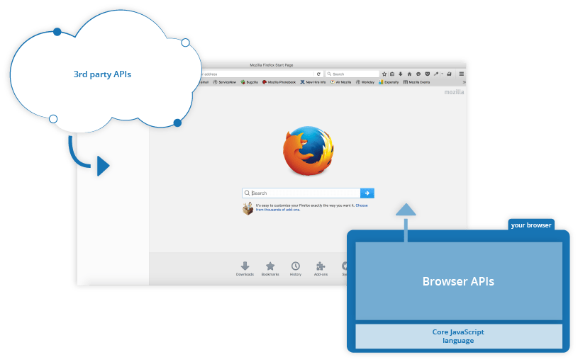
Browser APIs are built into your web browser, and are able to expose data from the surrounding computer environment, or do useful complex things. For example:
- The DOM (Document Object Model) API allows you to manipulate HTML and CSS, creating, removing and changing HTML, dynamically applying new styles to your page, etc. Every time you see a popup window appear on a page, or some new content displayed (as we saw above in our simple demo) for example, that's the DOM in action.
- The Geolocation API retrieves geographical information. This is how Google Maps is able to find your location and plot it on a map.
- The Canvas and WebGL APIs allow you to create animated 2D and 3D graphics. People are doing some amazing things using these web technologies —see Chrome Experiments and webglsamples.
- Audio and Video APIs like HTMLMediaElement and WebRTC allow you to do really interesting things with multimedia, such as play audio and video right in a web page, or grab video from your web camera and display it on someone else's computer (try our simple Snapshot demo to get the idea).
Third party APIs are not built into the browser by default, and you generally have to grab their code and information from somewhere on the Web. For example:
- The Twitter API allows you to do things like displaying your latest tweets on your website.
- The Google Maps API and OpenStreetMap API allows you to embed custom maps into your website, and other such functionality.
You can find out much more about these in our Client-side web APIs module.

What is JavaScript doing on your page?
Let's briefly recap the story of what happens when you load a web page in a browser (first talked about in our How CSS works article). When you load a web page in your browser, you are running your code (the HTML, CSS, and JavaScript) inside an execution environment (the browser tab). This is like a factory that takes in raw materials (the code) and outputs a product (the web page).
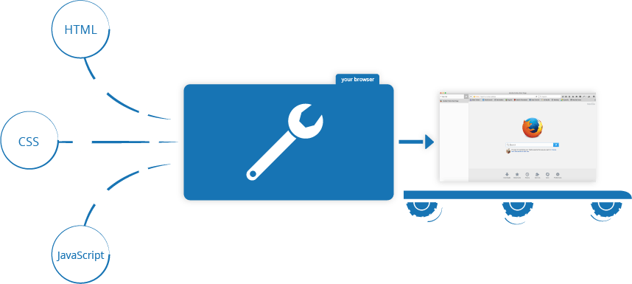
A very common use of JavaScript is to dynamically modify HTML and CSS to update a user interface, via the Document Object Model API (as mentioned above). Note that the code in your web documents is generally loaded and executed in the order it appears on the page. If the JavaScript loads and tries to run before the HTML and CSS it is affecting has been loaded, errors can occur. You will learn ways around this later in the article, in the Script loading strategies section.

Browser security
Each browser tab has its own separate bucket for running code in (these buckets are called "execution environments" in technical terms) — this means that in most cases the code in each tab is run completely separately, and the code in one tab cannot directly affect the code in another tab — or on another website. This is a good security measure — if this were not the case, then pirates could start writing code to steal information from other websites, and other such bad things.
Note: There are ways to send code and data between different websites/tabs in a safe manner, but these are advanced techniques that we won't cover in this course.

JavaScript running order
When the browser encounters a block of JavaScript, it generally runs it in order, from top to bottom.

Interpreted versus compiled code
You might hear the terms interpreted and compiled in the context of programming. In interpreted languages, the code is run from top to bottom and the result of running the code is immediately returned. You don't have to transform the code into a different form before the browser runs it. The code is received in its programmer-friendly text form and processed directly from that.
Compiled languages on the other hand are transformed (compiled) into another form before they are run by the computer. For example, C/C++ are compiled into machine code that is then run by the computer. The program is executed from a binary format, which was generated from the original program source code.
JavaScript is a lightweight interpreted programming language. The web browser receives the JavaScript code in its original text form and runs the script from that. From a technical standpoint, most modern JavaScript interpreters actually use a technique called just-in-time compiling to improve performance; the JavaScript source code gets compiled into a faster, binary format while the script is being used, so that it can be run as quickly as possible. However, JavaScript is still considered an interpreted language, since the compilation is handled at run time, rather than ahead of time.

Server-side versus client-side code
Client-side code is code that is run on the user's computer — when a web page is viewed, the page's client-side code is downloaded, then run and displayed by the browser.
Server-side code on the other hand is run on the server, then its results are downloaded and displayed in the browser. Examples of popular server-side web languages include PHP, Python, Ruby, ASP.NET and... JavaScript! JavaScript can also be used as a server-side language, for example in the popular Node.js environment — you can find out more about server-side JavaScript in our Dynamic Websites – Server-side programming topic.

Dynamic versus static code
The word dynamic is used to describe both client-side JavaScript, and server-side languages — it refers to the ability to update the display of a web page/app to show different things in different circumstances, generating new content as required. Server-side code dynamically generates new content on the server, e.g. pulling data from a database, whereas client-side JavaScript dynamically generates new content inside the browser on the client, e.g. creating a new HTML table, filling it with data requested from the server, then displaying the table in a web page shown to the user. The meaning is slightly different in the two contexts, but related, and both approaches (server-side and client-side) usually work together.
A web page with no dynamically updating content is referred to as static — it just shows the same content all the time.

Script loading strategies
There are a number of issues involved with getting scripts to load at the right time. Nothing is as simple as it seems! A common problem is that all the HTML on a page is loaded in the order in which it appears. If you are using JavaScript to manipulate elements on the page (or more accurately, the Document Object Model), your code won't work if the JavaScript is loaded and parsed before the HTML you are trying to do something to.
document.addEventListener("DOMContentLoaded", function() {
...
});
This is an event listener, which listens for the browser's "DOMContentLoaded" event, which signifies that the HTML body is completely loaded and parsed. The JavaScript inside this block will not run until after that event is fired, therefore the error is avoided (you'll learn about events later in the course).
In the external example, we use a more modern JavaScript feature to solve the problem, the defer attribute, which tells the browser to continue downloading the HTML content once the <script> tag element has been reached.
<script src="script.js" defer></script>
In this case both the script and the HTML will load simultaneously and the code will work.
Note: In the external case, we did not need to use the DOMContentLoaded event because the defer attribute solved the problem for us. We didn't use the defer solution for the internal JavaScript example because defer only works for external scripts.
An old-fashioned solution to this problem used to be to put your script element right at the bottom of the body (e.g. just before the </body> tag), so that it would load after all the HTML has been parsed. The problem with this solution is that loading/parsing of the script is completely blocked until the HTML DOM has been loaded. On larger sites with lots of JavaScript, this can cause a major performance issue, slowing down your site.

async and defer
There are actually two modern features we can use to bypass the problem of the blocking script — async and defer (which we saw above). Let's look at the difference between these two.
Scripts loaded using the async attribute (see below) will download the script without blocking rendering the page and will execute it as soon as the script finishes downloading. You get no guarantee that scripts will run in any specific order, only that they will not stop the rest of the page from displaying. It is best to use async when the scripts in the page run independently from each other and depend on no other script on the page.
For example, if you have the following script elements:
<script async src="js/vendor/jquery.js"></script>

<script async src="js/script2.js"></script>

<script async src="js/script3.js"></script>
You can't rely on the order the scripts will load in. jquery.js may load before or after script2.js and script3.js and if this is the case, any functions in those scripts depending on jquery will produce an error because jquery will not be defined at the time the script runs.
async should be used when you have a bunch of background scripts to load in, and you just want to get them in place as soon as possible. For example, maybe you have some game data files to load, which will be needed when the game actually begins, but for now you just want to get on with showing the game intro, titles, and lobby, without them being blocked by script loading.
Scripts loaded using the defer attribute (see below) will run in the order they appear in the page and execute them as soon as the script and content are downloaded:
<script defer src="js/vendor/jquery.js"></script>

<script defer src="js/script2.js"></script>

<script defer src="js/script3.js"></script>
All the scripts with the defer attribute will load in the order they appear on the page. So in the second example, we can be sure that jquery.js will load before script2.js and script3.js and that script2.js will load before script3.js. They won't run until the page content has all loaded, which is useful if your scripts depend on the DOM being in place (e.g. they modify one of more elements on the page).
To summarize:
- async and defer both instruct the browser to download the script(s) in a separate thread, while the rest of the page (the DOM, etc.) is downloading, so the page loading is not blocked by the scripts.
- If your scripts should be run immediately and they don't have any dependencies, then use async.
- If your scripts need to wait for parsing and depend on other scripts and/or the DOM being in place, load them using defer and put their corresponding <script> elements in the order you want the browser to execute them.

